The basic layout of the program starts with a repair shop. The customer and appointments are created as part of it, which are then used to create a replacement request. Staff works as the buffer between the repair shop and rolling wreck, processing the replacement request and sending it to the nearest site. The rolling wreck site sets up the delivery with an available rental car and driver. Once the repair job is finished, a pickup request is created and handled in a similar manner.

Part 1

Candidate Classes: repair shop, repair shop staff, RWC, RWC site , RWC staff customer, car, appointment, payment, staff/web site (computer), driver, rental car, rental car inventory, paperwork

Candidate Responsibilities: make appointment, request service (replacement/pick up) of car, make/track payment, calculate payment, get customer and customer’s car info, find closest site

Part 2 – Initial Set of CRC Cards

Repair Shop Staff
add customer  add appointment  add replacementrequest  add pickuprequest  find closestsite | Appointment  Customer  Payment  Staff  Paperwork

Appointment
set/get date  set/get time  set/get service (replacement/pickup) | Repair Shop  Customer

Customer
set/get name  add customer car | Repair Shop  Appointment  Customer Car

Customer Car
set/get model  set/get make  set/get size | Customer

Payment
calc weeklytotal  get weeklytotal | Repair Shop  Paperwork

RWC Staff
find closestvehicle | Repair Shop  Rolling Wreck Site

Rolling Wreck Site
set/get location  add rentalcar  add driver  add delivery  add pickup | Staff  Driver  Rental Car  Paperwork

Driver
set/get schedule  present rentalpaperwok | Rolling Wreck Site

Rental Car
set/get available  set/get make  set/get model  set/get size  set/get price | Rolling Wreck Site

Rental Paperwork
set/get rentalprice  set/get daylimit | Repair Shop  Rolling Wreck Site
UML Class Relationship Diagrams

1) Rolling Wreck Corp.

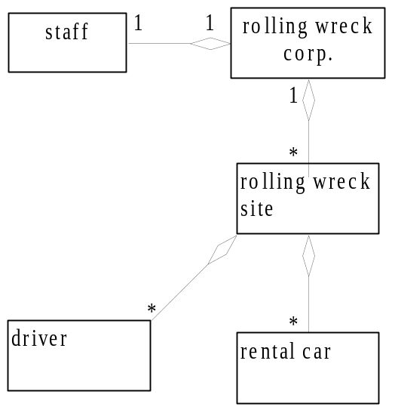

2) Repair Shop

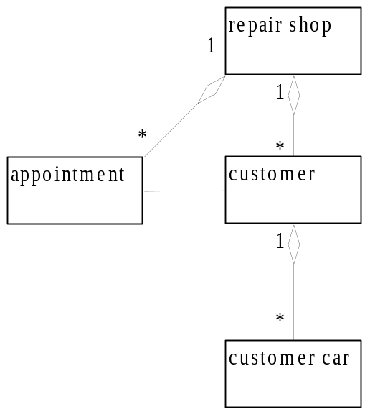
3) The Transaction

